- Explain what is RDF: Resource Description Format
- What does the following SPARQL queries returns?
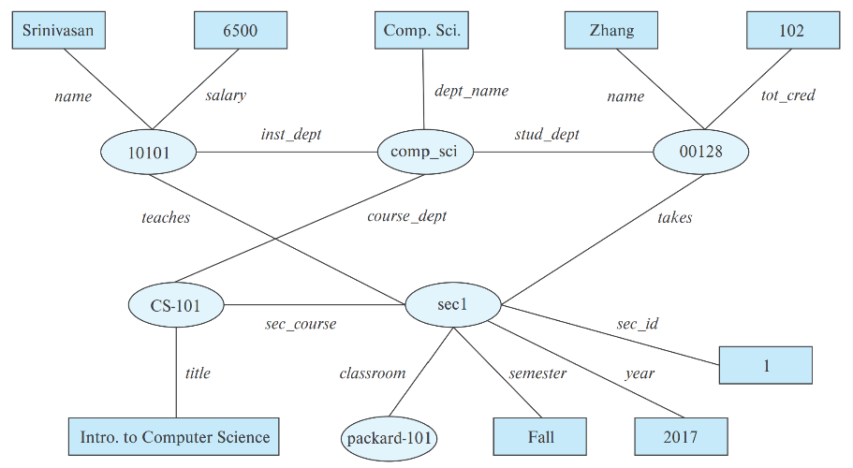
select ?name
where {
?cid title "Intro. to Computer Science" .
?sid sec_course ?cid .
?id teaches ?sid .
?id name ?name .
}

- Consider a simple web network with four web pages: A, B, C, and D. Each page initially has an equal PageRank score of 0.25 (1/4). If we calculate the PageRank scores iteratively, what would be the PageRank score of page B (P[B]) after the first iteration?
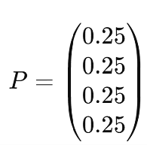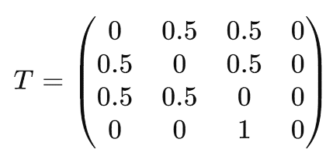
- From the ACID Properties, explain isolation and Atomicity
- Is the schedule a conflict serializable? Draw the Precedence graph  - Is the schedule a view serializable?  - Is the schedule a Cascadeless  - Is the schedule a Recoverable?
  $$T_{2}$$ | $$T_{1}$$
   | Read(A)
  A:=A-50
  Write(A)
  Read(B)
  Read(A)
  Temp:=A*0.1
  A:=A-temp
  Write(A)
  Write(B)
  B:=B+20
  Write(B)
  commit
  Read(B)
  B:=B+temp
  Write(B)
  Commit
- Write a summary of your research and studies in this semester and your future work.

Good Luck, Taghinezhad

Answer 1):
- RDF is a data representation standard based on the entity-relationship mode: Subject(Entity), Predicate(Attribute), Object(Value)
Answer 2)
Srinivasan
Answer 3: $P\left[j\right]=\frac{δ}{N}+\left(1-δ\right)* \sum_{i=1}^{N}{(T\left[i,j\right].P[i])}$

  - P[A]=0.15/4​+(1−0.15)×[(0×0.25)+(0.5×0.25)+(0.5×0.25)+(0.5×0.25)]= 0.35625
  - P[B]=0.15/4​+(1−0.15)×[(0.5×0.33)+(0×0.25)+(0.5×0.25)+(0×0.25)]= 0.0375+ 0.85*(0.29)=0.284

Answer 4:

Answer 5) 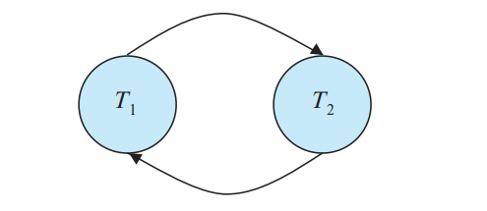, Answer6: خیر, Answer 7: خیر, Answer 8: بلی

